How to use Adept File I/O

Objective
The goal is to demonstrate the operation of Adept File I/O using a (16 x 32) register array.
In this demonstration we read from an input file (input_file.txt) sixteen 8-digit numbers (00000000 – 99999999) then store it in reverse order in the register array. For example, 123456789 will be stored as 987654321. Later we read from the register array and write it to the output file (output_file.txt).

Procedure

Step 1: Create a new project and add the two files:
- EE201_Adept_File_IO_demo.v
- EE201_Adept_File_IO_demo.ucf (just a copy of your Divider_top_with_VIO.ucf with the file name changed).
Actually it is not important to change the file name.
We can add Divider_top_with_VIO.ucf as it is, but it is a little confusing.

Step 2: Synthesize, Implement, and Generate the bit file.
Do not forget to change the default CCLK to JTAG Clock under the Startup options.
Recall that first you need to right-click on Generate Programming File and choose Properties. Then select Startup options.
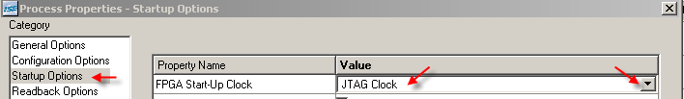
Step 3: Download the bit file onto the FPGA using Adept 2.x (2.0 or 2.1 or 2.3)
Note: In the above design file, EE201_Adept_File_IO_demo.v, we chose randomly, addresses 41 (0x29 in hex) for the register for streaming data into the FPGA during uploading a file from the PC to the FPGA and streaming data out of the FPGA during downloading a file from the FPGA to the PC.
The design, EE201_Adept_File_IO_demo.v, basically handles the streaming in of data through register 41, processing the data, and later streaming out data through register 41 again.
It is possible that we may have to exchange multiple files. Each file needs to be associated with its appropriate memory array (for example, Instruction Memory, Data Memory, and Register file in EE560). A simple method can be implemented in our logic for the user to convey to our Board. An additional register, say register 42, can be used by the user to deposit a 0 or 1 (or even 2) to specify which one of the multiple transactions, he is currently initiating. In this demo, transaction with only one item in the FPGA is planned and hence this is not implemented.
In this demo, the memory array is actually implemented as an array of registers. While in most applications, we start filling the memory array with the contents of the file on PC starting from the location zero, we provided a convenience flexibility for the user to load the data from any starting address (not necessarily a zero). So we used a register with address 40 (0x28 in hex) for the user to specify the starting address in memory. In this demo you deposit a zero in this register 40 and the logic starts depositing the first line at memory location zero. In our logic we have a line_pointer register which is written with zero when the user write a zero in the Epp Data register 40. We increment the line pointer register every time we finish receiving (or sending) a line of data. At the end of the file transfer, user can read back this register 40 to read the contents of the line_pointer to see if the line_pointer got incremented as expected.

The Adept GUI provides Register I/O services tab besides File I/O services tab. So the procedure below asks you to use the Register I/O tab in adept and write a zero into the register with address 40 before streaming in or out data through register 41.
Download the Demo bit file to your Nexys board and follow the directions on the next few pages to download and upload files.

Procedure to upload a file (upload = PC to FPGA):

Step 1: Go to the Register I/O tab and send a data of 0 to location 40 (address pointer).

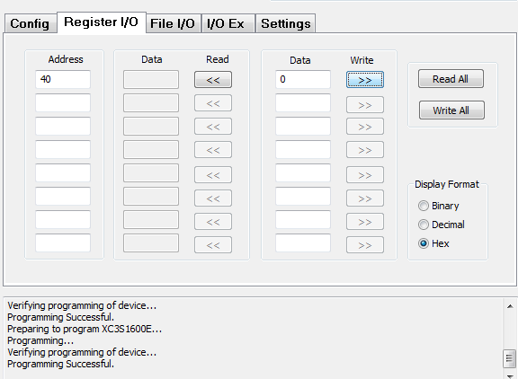

Step 2: Read from the location 40 to verify it’s written correctly.

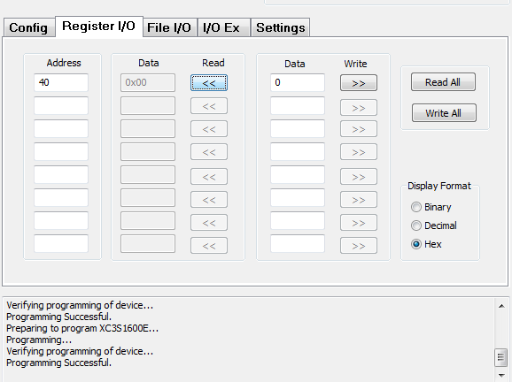

Step 3: Go to the File I/O tab and select the file to be uploaded (from PC to the FPGA) and how many bytes you would like to read. Make the register address to be 41.

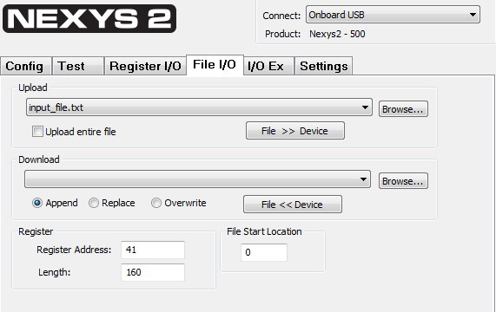
Unimportant

The file length is 160 characters, as we are sending 16 lines of characters and each line has 10 characters. The 10 characters include the two ASCII characters for the carriage return and line feed at the end of the line, besides the 8 numeric characters.

Repeat steps 1 to 3 for any new upload of files.

Procedure to download a file:

Step 1: Go to the Register I/O tab and send a data of 0 to location 40 (address pointer).

Step 2: Read from location 40 to verify it’s written correctly.

Step 3: Go to File I/O tab and choose to download (FPGA to PC) by selecting to “Overwrite” any existing file with the matching name. Browse and select the file (file name) to be downloaded and how many bytes you would like to read. Make the register address to be 41.

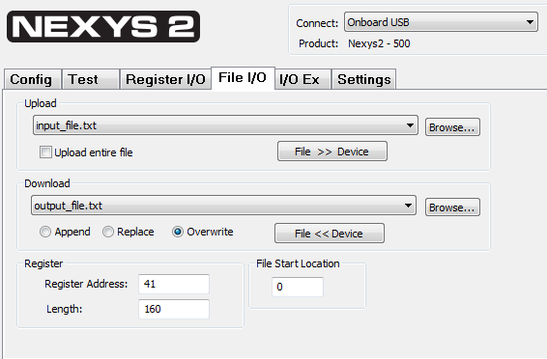

The file length is 160, as we will be receiving 16 lines of characters and each line has 10 characters. The 10 characters include the two ASCII characters for the carriage return and line feed at the end of the line, besides the 8 numeric characters.

